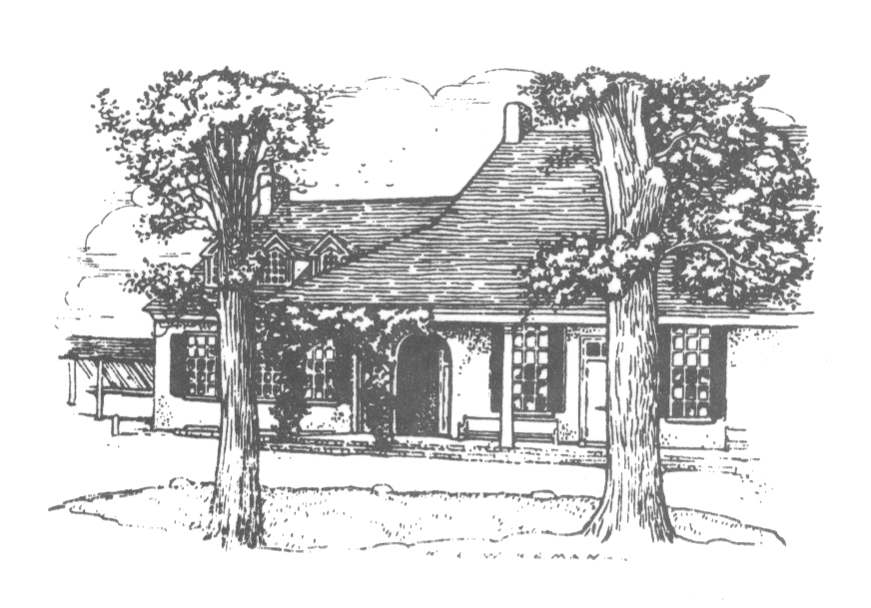
Join us for…

The Green Street Messenger

Green Street Messenger
monthly calendar & newsletter of…
Green Street Monthly Meeting of Friends
45 West School House Lane
Philadelphia, PA 19144
West Philadelphia Preparative Friends Meeting
1018 S 48th St (Squirrel Hill Apartment Bld.
Basement)
Philadelphia, PA 19143

First Day Meeting for Worship 10:30 am
First Day School 10:30–11:15 am
First Day Meeting for Worship at West Phila. Mtg. 1:30 pm
Wednesday morning Meeting for Worship 8:30–9:00 am with GSFS
First Sunday evening Meeting for Worship 6:30–7:00 pm at Stapeley Hall
267-285-0553 / secretary@greenstreetfriendsmeeting.org Office hours: 9:45–12:45 Mon.–Fri.

For updates and more information: go to greenstreetfriendsmeeting.org

February 2017

Sunday, 5th 9:30 am Breakfast with a Friend—JoAnn Seaver/Bill Van Stone
Rise of Meeting Coffee Hour—Gabriel Ehri
12:30 Care & Counsel Committee Meeting

Sunday, 12th 9:00 am Second Sunday Forum - Quaker social change ministry
(Please see the About F/friends section)
Rise of Meeting Coffee Hour—Traci & Walter H. Sullivan

Sunday, 19th Rise of Meeting Lunch—Blythe & Eric Davenport
12:45 Meeting for business

Sunday, 26th 9:15 am Friendly Bible Study
Rise of Meeting Coffee hour—Charlotte Anderson and Lucy Duncan



Minutes of Monthly Meeting for Business Held First Month 15, 2017
At Green Street Monthly Meeting of the Religious Society of Friends, held at 45 West School House Lane, Philadelphia, Pennsylvania, on First Month 15, 2017: Business Meeting convened at 12:45 pm in prayerful silence.

17-01-01 The Clerk welcomed Friends, asking them to introduce themselves and share feelings about MLK Day and the Inauguration.

17-01-02 Friends approved minutes from Twelfth month.

17-01-03 Friends reviewed, amended and assented to the agenda.

17-01-04 Consideration of the Minute from the Fellowship of Friends of African Descent
Ayesha Imani, a member of Germantown MM, introduced the Fellowship of Friends of African Descent, which has three main concerns: the support and nurturing of friends of African descent; addressing issues of race and racism in the Religious Society of Friends; addressing concerns from the communities from which members of the Fellowship come from. The Fellowship is focusing its attention on this third concern.

She and Valerie Anderson read the minute in full.

The Fellowship is asking to be held in the Light, for Meetings that endorse this minute to pray for and with them, and to query them with concerns they need to consider, and to help them make connections to people and resources.

The Fellowship feels that they are standing in the intersection of Quakerism and Africanity, asking the larger body of Friends to hold them spiritually accountable and help the Fellowship think clearly about this leading. While the Fellowship of Friends of African Descent seeks to work with groups and organizations of all kinds, they see this moment as a chance to come together, to work in harmony with other groups. The Fellowship wants to take the opportunity to do activism rooted in Quaker faith and Quaker process, seeing that there is a unique contribution that Quakers and Friends of African Descent can make at this time.

Friends were directed to ask about concerns that might lead us to not endorse the minute.

Friends expressed concern about investments, possible conflicts with energy and resources that might stretch the Meeting’s capacity, and asked for clarity around some of the language in the minute.

Friends also expressed great excitement at feeling called to join the Fellowship under the weight of the concern that fits in with the work that Green St. MM is doing now. Friends expressed enthusiastic willingness to unite with this request, and the next step can be brought before the Meeting before any further commitment is made.

While holding Friends’ concerns as important, the sense of the Meeting was one of deep privilege at being asked to endorse this minute. The minute reflects the passion and energy that is building at Green St. MM around issues of race and justice.

Green St. MM endorses this minute with faithful rejoicing.

17-01-05 Discussion for approval of the Worship and Ministry Committee offer to be point persons for 2nd Sunday
Traci Hjelt Sullivan, co-clerk of W&M, revisited the offer of W&M to act as a scheduling and discernment body for the Second Sunday forums, which was made during last business meeting. This committee is appropriate because it is equipping Friends for ministry. W&M would manage the schedule and publicize sessions and help examine the subjects, but not run the forums. This process would be in place until summer, and then revisited. The Meeting gratefully approved.

17-01-06 Update the rug decision process
Before starting, Friends held the memory of Ethel Trefsger in appreciation.

Jim Dragoni, member of the Property Committee, updated the Meeting on the rug decision. He showed carpet samples that may be options to replace the carpet in the meeting house and reported that the School would like to have this completed before graduation. Along with considerations of painting, fixing the floor, and getting the blinds restrung, there is some urgency. The rug-selecting group has not yet been formed, but will be charged with researching the effects of these improvements on people with chemical sensitivities. The Assistant Clerk will contact the Clerk of the Property Committee to form this group quickly. The Property Committee will decide the order in which carpet, painting, and blinds will be done.

17-01-07 Nominating Committee
Walter Hjelt Sullivan, Clerk of the Nominating Committee, read the nominations held over from Twelfth Month 2016.

GSMM Clerk – JoAnn Seaver – 2/2017 to 6/2018
Property Clerk – Dan McDevitt – 2/2017 to 6/2018
Property – Robin Mohr – 2/2017 to 6/2018
Care and Counsel – Jim Hood – 2/2017 to 6/2019
Care and Counsel – Susan Chast to replace Pamela Draper for WPPM
Recording Clerk – Blythe Davenport – 2/2017 to 6/2019
Assistant Recording Clerk – Walter Hjelt Sullivan – 2/17 to 6/2018

Friends approved these nominations.

He read names ready for first reading 1/15/17
Asst. Clerk - Anthony DiGiovanni - 2/2017 to 6/2017
Care and Counsel - Gabriel Ehri - 2/2017 - 6/2019
Archivist - Geniver Montalvo - 2/2017 - 6/2019

Friends approved Anthony DiGiovanni’s nomination and will consider the other names until the next business meeting. If there are any concerns about the two names, please contact the Nominating Committee before the next business meeting.

The Nominating Committee will gather feedback about the Archivist position to clarify where that position fits in to the structure of the meeting. Members with suggestions are encouraged to contact the Nominating Committee.

17-01-08 – Care and Counsel – Survey Friends’ interest in a Meeting Retreat
Charlotte Anderson, Clerk of Care and Counsel, reports that the Committee is hoping to hold a one-day retreat in the spring. The Committee has created a brief survey about Friends’ interest in where, what, how and other considerations for the retreat. Please look in your email and on paper for the forthcoming survey.

17-01-09 – Worship and Ministry – Report on Signage
Walter Hjelt Sullivan, co-clerk of W&M, reported on setting up a committee to work with the school on joint signage. Ed Marshall, Terri Hamer, Anthony DiGiovanni and Cheryl McFadden met to discuss shared signage. The School and the Meeting are in agreement that a joint sign can be placed on the corner of Greene St and Schoolhouse Lane. The Committee recommends that some signage identifying the meetinghouse should also be created. Friends encouraged the committee to avoid nostalgia and embrace a contemporary aesthetic as they design the signage. There is also a commitment to have young people involved in the process.

17-01-10 - These minutes were approved.

17-01-11 - Friends ended in worship

Meeting adjourned, agreeing to meet again at the appointed time on Second Month 19, 2017.

Anthony DiGiovanni, Assisant Clerk
Blythe Davenport, Recording Clerk

Members present: Charlotte Anderson, Valerie Anderson, Mina Baisch, Susan Christian, Blythe Davenport, Anthony DiGiovanni, Robert Dockhorn, Andrew Dragoni, Jim Dragoni, Victoria Greene, David La Fontaine, Chris Mohr, Robin Mohr, Frank Perch, Traci Hjelt Sullivan, Walter Hjelt Sullivan, Margaret Walters

Attenders present: Rebecca Grant

Guest: Ayesha Imani

Staff: Gail Woodbury, Secretary

About our F/friends
(News and announcements of concern to the Meeting)

Meeting for Worship at Stapeley on the first Sunday of the month.
Stapeley residents will happily welcome anyone who wants to join them in their meeting for worship at 6:30.

Sunday, Feb. 12, 9:00 am, the Second Sunday Forum, Quaker social change ministry with Lucy Duncan
Want to bring mystics and activists together for powerful spiritual work in the world? In this workshop Friends will learn the key elements of a small group social change ministry model focused on creating the Beloved community by practicing restorative justice and respectfully companioning communities most impacted by injustice. Friends will learn how companioning, reflecting, storytelling, and acting together with a committed group can help to create sustainable, spiritually grounded, deeply connected work for a more just and peaceful world. Together we will experience several aspects of the model and reflect on how this can support our meetings in reclaiming our spiritual power and our social testimonies. We will explore how this model could support the ministry of Green Street Meeting in supporting EMIR or other community based organizations. Please join us in the social room. Childcare will be provided.
Share what’s happening at Green Street Meeting.
The Website Working Group is looking for photographs (with captions), descriptions of Meeting events, and short opinion pieces. We are happy to help with editing. Please submit to geniverm@yahoo.com. Items that you would like added to the Google calendar on our website should be submitted to the Meeting secretary at secretary@greenstreetfriendsmeeting.org.

[[[[[[[[[[[[

The Second Query on Meeting for Business
Is our meeting for business held in the spirit of a meeting for worship in which we seek divine guidance?
Are we careful to keep in the spirit of worship each of the concerns that emerge, whether of nurture, of Spirit, of social concerns, of property, or of finance?
Are Meeting decisions directed by prayerful consideration of all aspects of an issue and are difficult problems considered carefully with patient search for truth, unhurried by the pressures of time?
How do we respond if we notice the meeting has lost an understanding of the presence of God?
Do we recognize that we speak through our inaction as well as our action?
Do I regularly attend meeting for business and in a spirit of love and unity? If unable to attend, how do I attend to my responsibility?
Do I consider prayerfully the many concerns that are lifted up on any issue, acknowledging that the search for truth in unity involves what God requires, being open to personal transformation as the community arrives at the sense of the meeting?

[[[[[[[[[[[[

Contact information for major Quaker Organizations
American Friends Service Committee | Quaker values in action https://www.afsc.org/
Friends Committee on National Legislation https://www.fcnl.org/
Friends General Conference | Nurturing faith and Quaker practice www.fgcquaker.org/
Friends Journal: A Quaker magazine to connect and deepen spiritual ...www.friendsjournal.org/
Friends World Committee for Consultation Section of the Americas ...fwccamericas.org/
Registration for the 2017 Section Meeting is now open.
Philadelphia Yearly Meeting - Home www.pym.org

News and Announcements

Workshops and/or Short Courses at Pendle Hill
The Pendle Hill website now lists one day events, weekends and weeklong events. Please call Pendle Hill at (610) 566-4507 or (800) 742-3150, ext. 3, or go to pendlehill.org. Matching scholarships are available; please call. For more information, please go to their website, pendlehill.org, or call.

February 10-12, Middle School Friends Gathering, Kennett Monthly Meeting
Middle School Friends will convene at Kennett Monthly meeting for a cozy winter weekend. Ice skating will ensue at our popular annual field trip, followed by hot cocoa, of course! We will hope for snowy adventures for our outdoor games, and plan for indoor fun no matter what. As always, we will enjoy worship sharing, meaningful workshop and community building.
Details: www.pym.org/event/middle-school-friends-february-gathering/?instance_id=423 or Tara Rubinstein, trubinstein@pym.org

February 24-28, Young Friends Winter Gathering, Haddonfield Friends Meeting
Living in the Future! Young Friends gatherings create a fun and vibrant community of high-school-aged Quakers and Quaker-friendly folks. Info: Hannah Mayer, hmayer@pym.org or
www.pym.org/event/2615-2/?instance_id=385
Looking Ahead: March

March 4, Extended Meeting for Worship ,Swarthmore Friends Meeting
Would you like to deepen your experience of Worship? Have you wished that worship didn't end when the clock struck the hour?
The Worship and Care Standing Committee and the Meeting on Worship and Ministry invite you to experience Extended worship. Attend just a portion of the day or the full day. And remember to bring your lunch. All are welcome. If you will need childcare, email us by Monday, February 20. Details: Lola George, lolageorg@gmail.com
www.pym.org/event/2017-extended-meeting-for-worship-swarthmore/?instance_id=315

Saturday March 11, PYM Grant Makers Potluck, 11:30 am -1:30 pm, Arch Street Meetinghouse.
PYM's Granting Committee invites all PYM Granting Group members to gather for fellowship and appreciation of your grant making on behalf of PYM.
Details will be e-mailed. Contact Carol Walz at cwalz@pym.org or (215) 241-7201. If you will need childcare, RSVP to grants@pym.org by February 16, 2017.

March 18-21, FCNL Spring Lobby Weekend (Funding is available for YAF's)
The FCNL Spring Lobby Weekend will be held on March 18-21, 2017 in Washington DC. FCNL stands for Friends Committee on National Legislation. At this year's Spring Lobby Weekend, attendees will be trained on how to push our congress to enact laws that work to eliminate economic injustice. Details: (FCNL) www.fcnl.org/updates/spring-lobby-weekend-30
(Yaf Funding) www.pym.org/fcnl-spring-lobby-weekend-funding-available-yafs

Humor Corner: As you may know, in a shalom race the skier must pass through about 20 "gates" in the fastest time. Well, it happened that Israel had the fastest slalom skier in the world and had great expectations for an Olympic gold medal. Came the day of the final, the crowd waited in anticipation. The French champion sped down the course in 38 seconds. The Swiss in 38.7 seconds, the German in 37.8 seconds and the Italian in 38.1 seconds. Next came the Israeli's turn ... the crowd waited, and waited...six minutes! "What happened to you?" screamed his trainer when the Israeli finally arrived. Replied the exhausted Israeli: "Which of those idiots put a mezuzah on each gate?"

Quote Corner: Peace is a gift, but it does not come magically through our passivity. Only in our faithful response to God’s call do we receive God’s peace. -- Sandra Cronk

The submission deadline for the March newsletter is 9:30 am on Friday, February 17.

